**Media Sources:**

“computer_handshake.jpg”: http://farm8.staticflickr.com/7072/7223384344_4c7173c228.jpg

“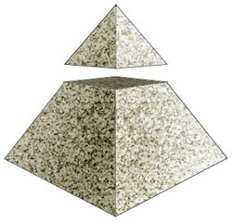capstone_icon.png”: http://staff.mq.edu.au/custom/files/media/ltc_capstone.jpg

“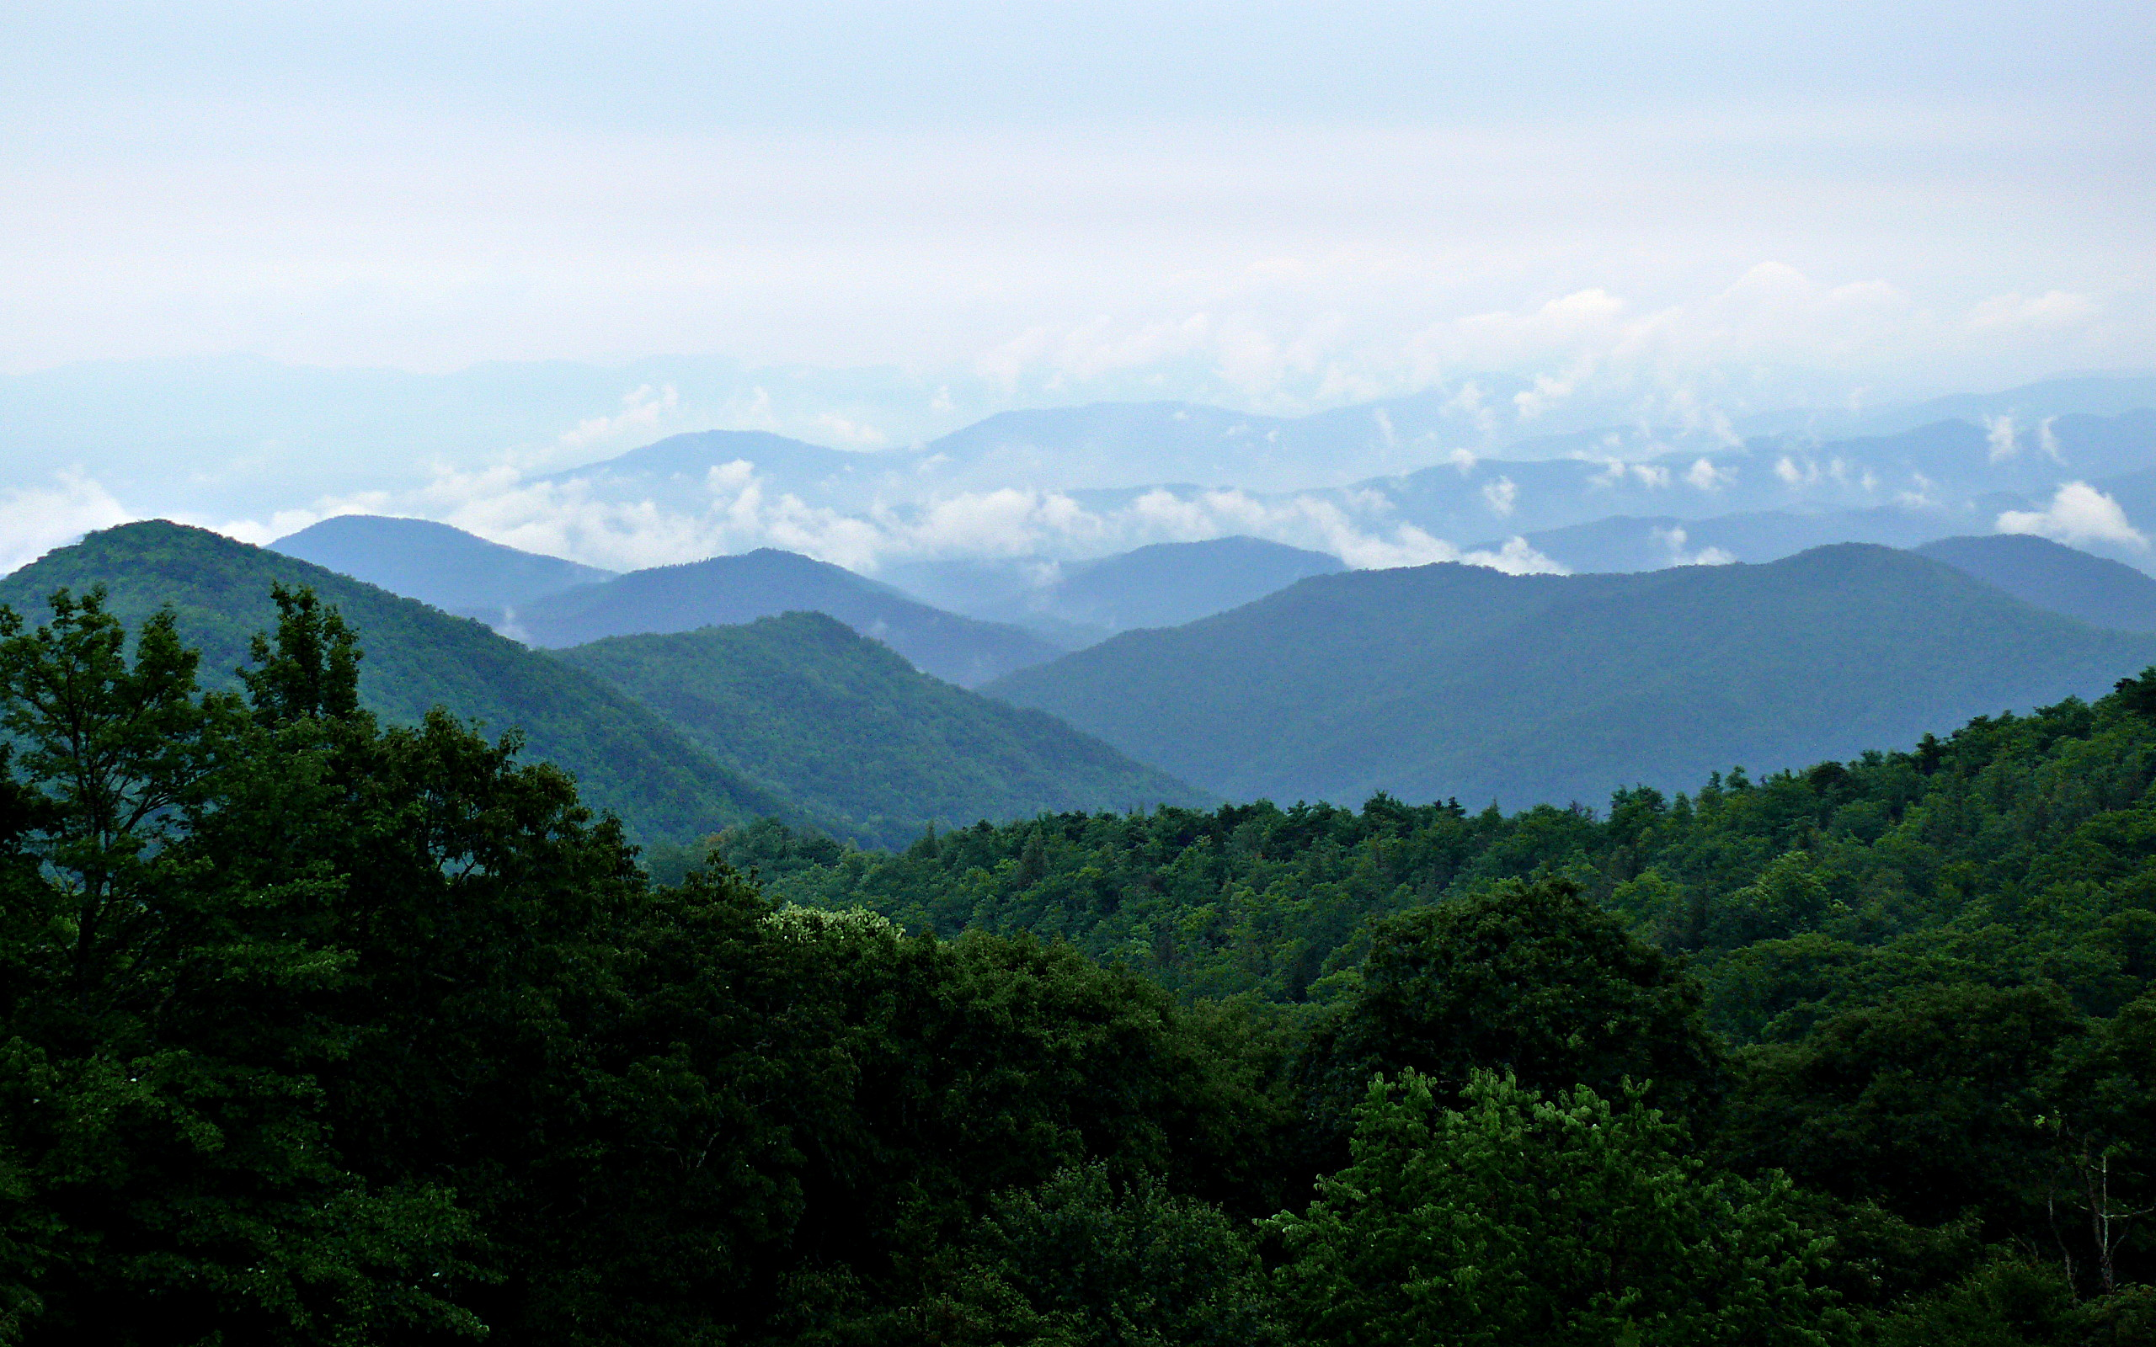tranquil_mountain_bg.jpg”: http://upload.wikimedia.org/wikipedia/commons/3/3c/Rainy_Blue_Ridge-27527.jpg

“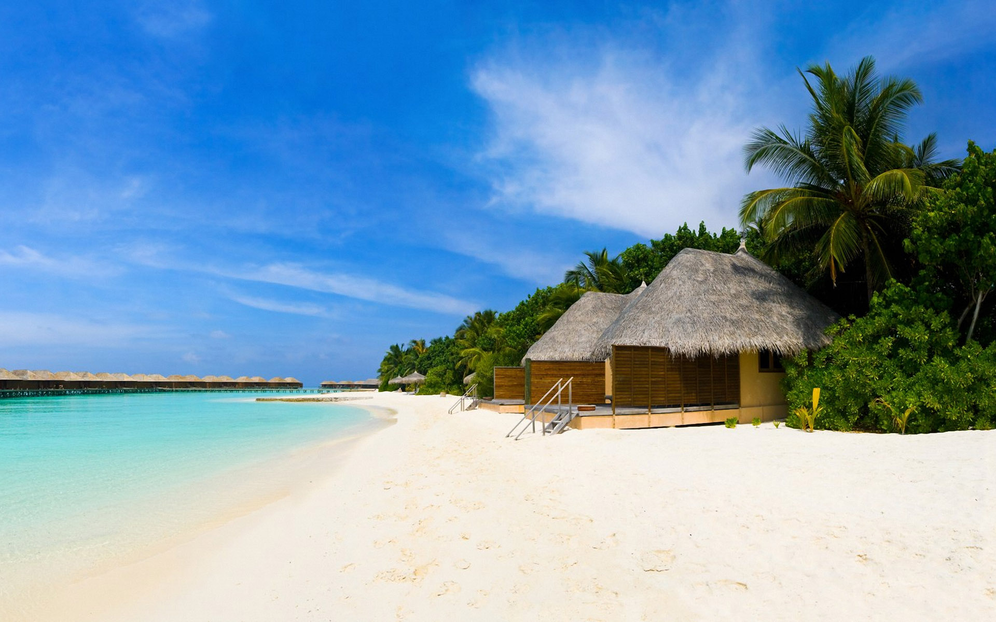tropical_shores_bg.jpg”: https://www.flickr.com/photos/victoriawhite/4973140074

“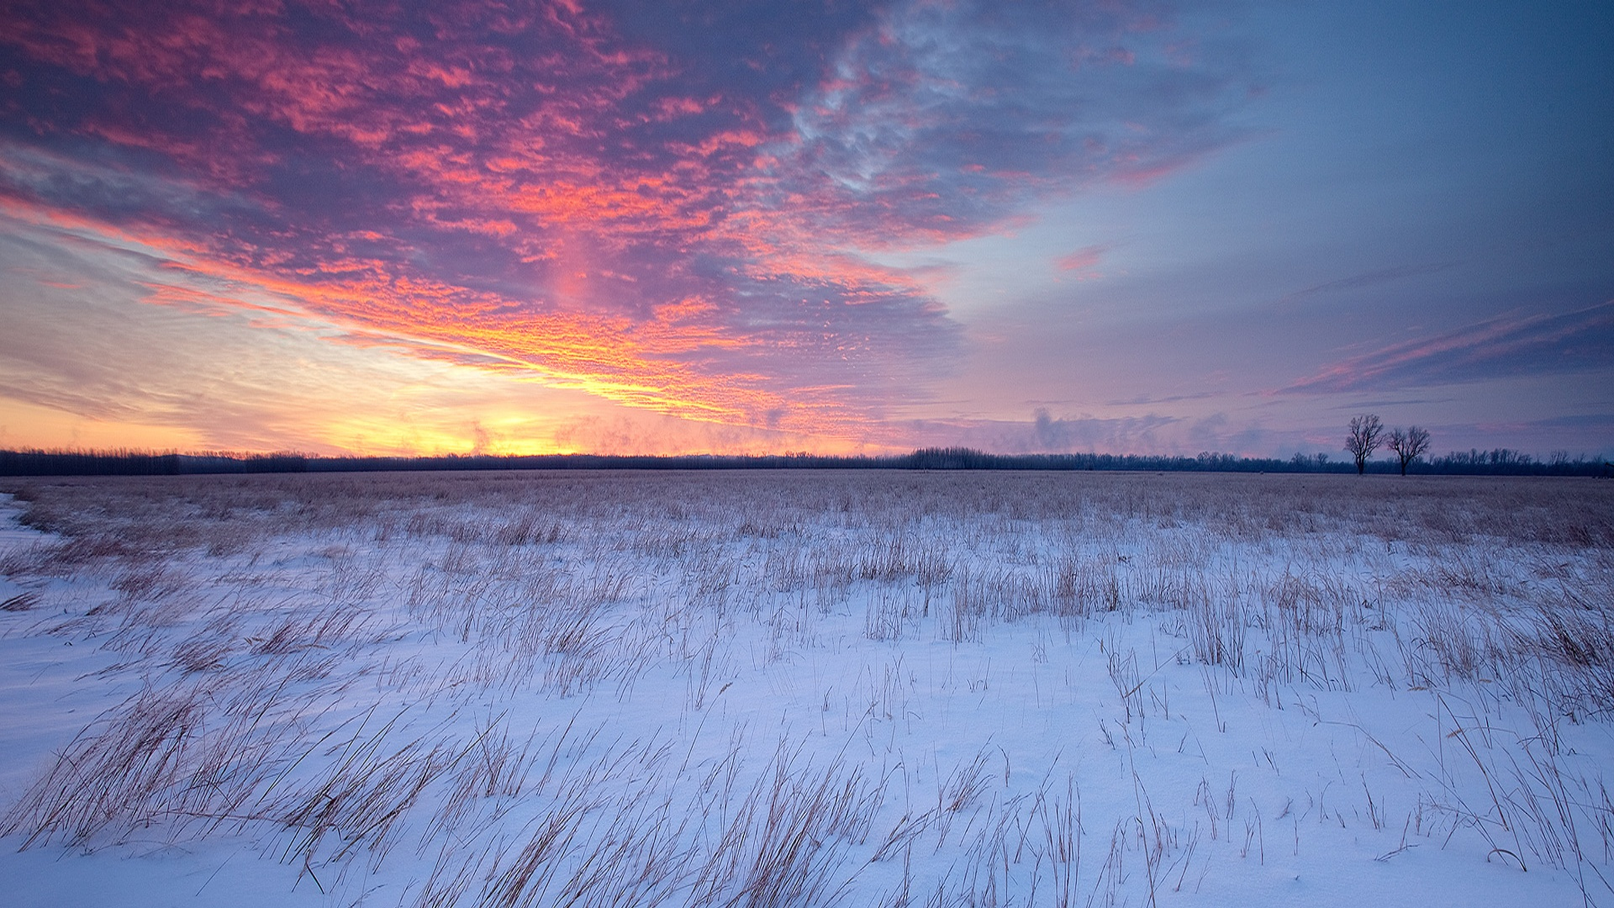winter_sunrise_bg.jpg”: http://7-themes.com/data_images/out/24/6852056-prairie-wallpaper.jpg